The HES
Homologation specification
v.1.6
This document contains proprietary information of Enel Global Digital Solutions and should only be used by the recipient in relation to the purposes for which it was received. Any form of reproduction or dissemination is forbidden without the express consent of Enel Global Digital Solutions.
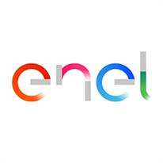
Redatto da: | Federica Di Rienzo | 22/12/2020
Verificato da: |  | 22/12/2020
Approvato da: |  | -

Control de Cambio

Revisión | Fecha | Descripción
Creación | 22/12/2020 | Elaboración de documento
Rev1 | 07/10/2021 | Se actualiza diagrama de solución ENEL de la página 28
Index
1. Introduction 4
1.1. Purpose 4
2. Especificación técnica de Sistema de Gestión y Operación 5
2.1. Collected information 8
2.1.1. Events 8
2.1.2. Readings 9
2.1.3. Load profiles 9
2.1.4. Alarms 10
2.1.5. Voltage variation 10
2.1.6. Voltage interruption 10
2.1.7. Measurands 11
2.2. Reachability 12
2.2.1. Concentrators 12
2.2.2. Meters 12
2.2.3. Event 13
2.2.4. Report 13
2.3. Alarms 14
2.3.1. Meters 14
2.3.2. Concentrators 15
2.4. Features 16
3. Especificación técnica de Sistema de Seguridad 17
3.1. Meter and concentrator keys 17
3.2. Logs 17
3.3. Data Integrity 17
3.4. Data Confidentiality 17
3.5. User permissions 17
4. Especificación técnica de Sistema de Comunicaciones 18
5. Especificación técnica de Sistema de Sincronización Horaria 19
5.1. Meters 19
5.2. Concentrators 20
6. Especificación técnica de Sistema y Aplicaciones 21
7. Especificación técnica de DB para Operador de Datos 22
8. Especificación técnica de Interfaces para Interoperabilidad (relativa a la Plataforma y medios de comunicación ) 23
8.1. I0 23
8.2. I1 23
8.3. I6 23
8.4. I7 23
8.5. I8 24
8.6. I9 24
8.7. I10 24
9. Especificación técnica de Almacén de Datos y Reportes 25
9.1. Website 25
9.2. Daily csv 25
9.2.1. Daily extraction from read-only database 25
9.2.2. Daily files from integration 26
9.3. Local database 27

Introduction

Purpose
The aim of this document is to describe specification required for homologation.

Especificación técnica de Sistema de Gestión y Operación

The HES has in its internal database the list of meters and POD (Point of Deliver). The provisioning of these information can be done from web site (one by one and massively) and via integration (automatically).

On website specific reports that allows to see the list and the status of meters and PODs are available.
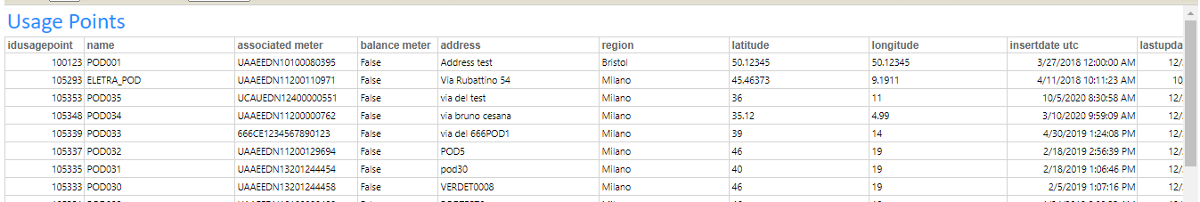

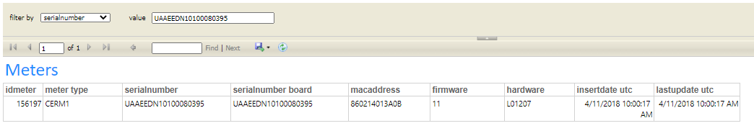

Each POD is identified from a specific address and specific coordinates (latitude and longitude) in order to show exact position on the map.

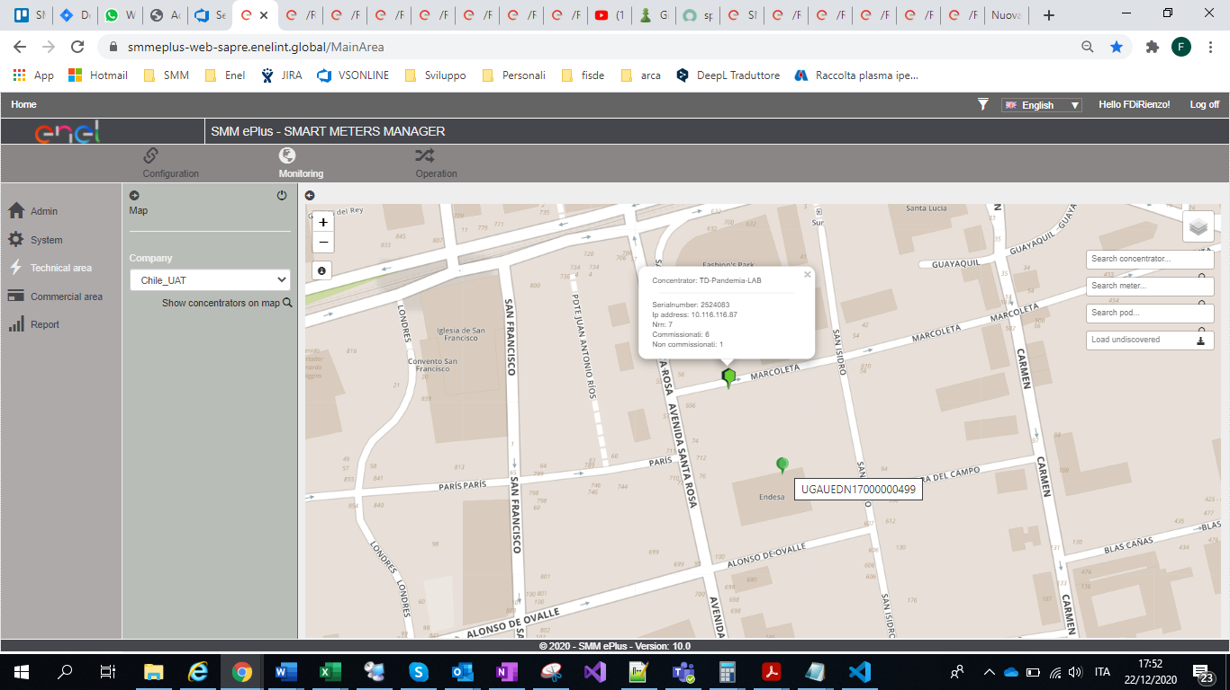

It’s possible to create, update and delete the associations between meters and PODs.
These operations can be done from web site (one by one and massively) and via integration (automatically).

There are specific reports regarding the relationship between meters and PODs.
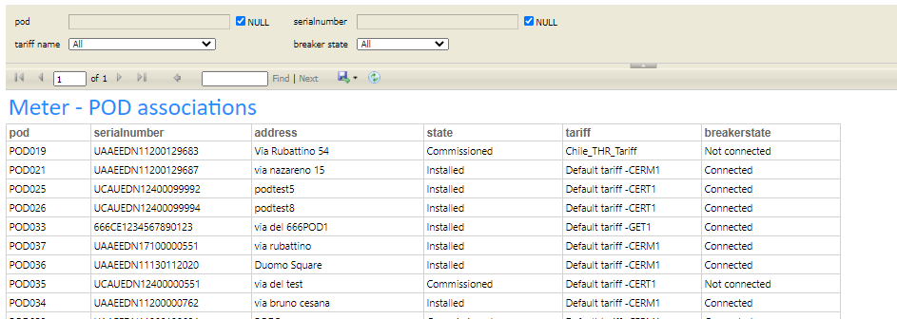

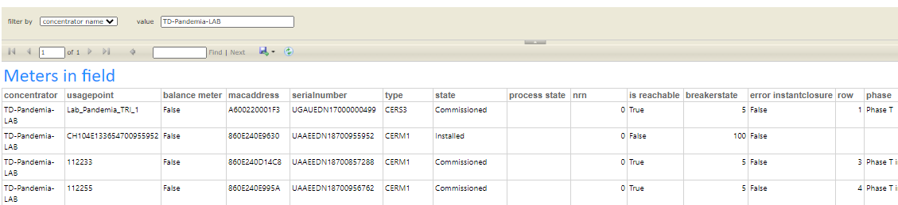

In addition, automatic csv are extracted every day.

The relationship between the meter and the concentrator is managed by The HES:
the association is usually done automatically when a meter is discovered by the concentrator, but can also be modified manually.

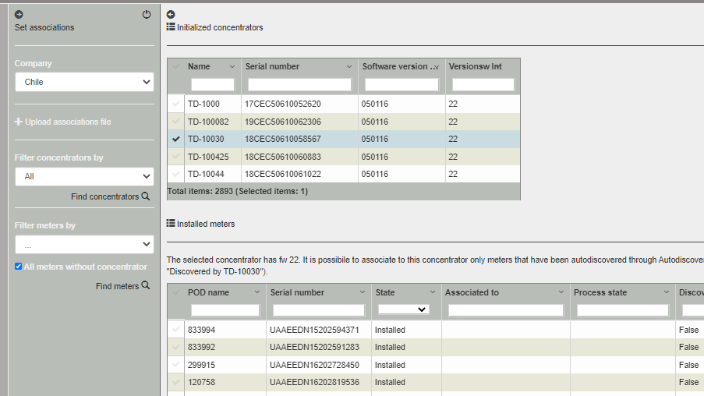

In the website it is possible to see meters that have been discovered by the concentrator, but with an automatic association not possible.

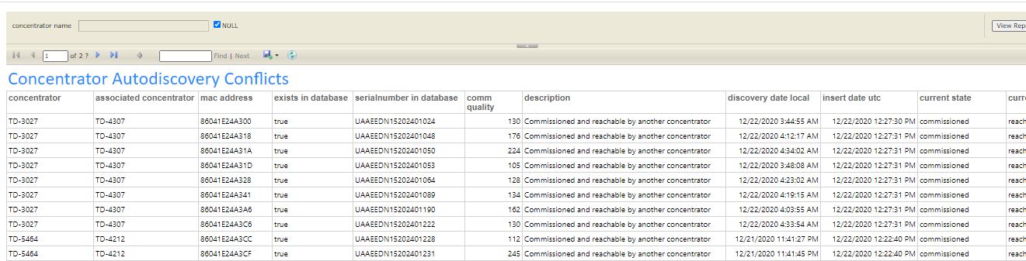

When an association is done, the concentrator tries to recruit the meter; this operation can be automatic or manual.

If this recruitment is completed successfully, the system automatically creates two configuration activities:

- The first is the technical configuration of the meter: clock synchronization, daylight saving time configuration, load profile interval, switch from public meter keys to private keys.
- The second is the technical configuration of the meter inside the concentrator: the concentrator needs to know which load profile and readings collect for that meter.

When this flow is completed, the meter is automatically read by concentrator several times per day (depending on system configuration).

Meters can be read and manages remotely (if recruited by a concentrator) or locally, using Android application.

Collected information

All the information collected by the system are shared with local integration system that is in charge of the storage. Each information is exported with the identification of the device, the timestamp and an attribute indicating the kind of information.

The exported information are:
- Pushed on cloud queues that can be consumed
- Appended on daily csv files

The share of information is described in SMMePlus - Architecture v4.0 document in section 2.5. SMMePlus Integration Service application.

The kind of information collected by the system are:
- Events
  - Massive events are exported.
- Readings
  - Statistic information are saved in internal database.
  - Last current period reading for active energy for each meter is saved.
  - Massive readings are exported.
- Load profiles
  - Statistic information are saved in internal database.
  - Massive load profiles are exported.
- Alarms
  - Massive alarms are exported.
- Voltage variation
  - Massive voltage variation are exported.
- Voltage interruption
  - Last interruption values per each meter are saved internally.
  - Massive voltage interruption are exported.
- Measurands
  - Statistic information are saved in internal database.
  - Massive measurands are exported.

Events

This an example of csv file generated daily by the system. The same information are pushed on cloud queues.

- HPE file contains high priority events (results of workorder).
- LPE file contains events with normal/low priority (reachability, commissioning, spontaneous messages).

Readings

This an example of csv file generated daily by the system. The same information are pushed on cloud queues.

- R file contains current period readings.
- DC file contains previous period readings (used for billing).
- MP file contains maximum power on demand readings.
- PP file contains readings related to prepayment feature.
- M file contains measurands registers.

On the front-end there are several reports showing statistic information and last collected information.

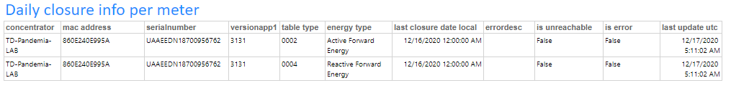

Load profiles
This an example of csv file generated daily by the system. The same information are pushed on cloud queues.

On the front-end there is a specific report showing statistic information about load profile collection.
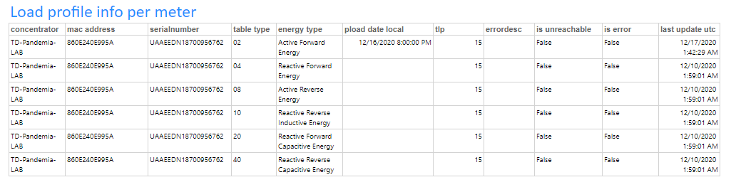

Alarms

This an example of csv file generated daily by the system. The same information are pushed on cloud queues.

Voltage variation

This an example of csv file generated daily by the system. The same information are pushed on cloud queues.

Voltage interruption

Every day a specific csv is created containing collected voltage interruptions. The same information are pushed on cloud queues.

On the front-end there is a specific report showing last interruption information per each meter.

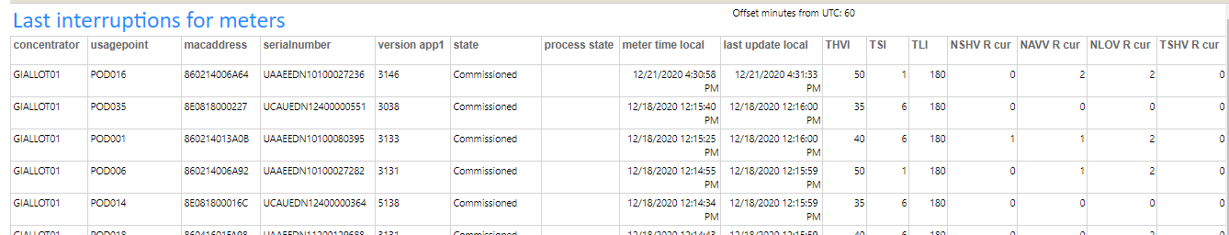

Measurands

Every day a specific csv is created containing collected measurands. The same information are pushed on cloud queues.
On the front-end there is a specific report showing statistic information about measurands collection.

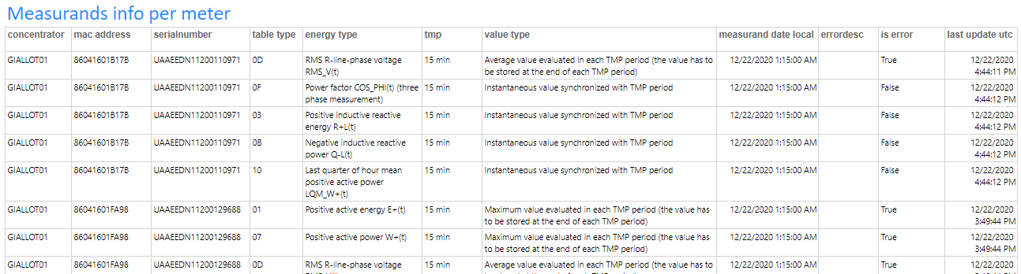

Existing measurands registers in meters are:

MSR_TYPx | Description | Note
0x01 | Positive active energy E+(t)
0x02 | Negative active energy E-(t)
0x03 | Positive inductive reactive energy R+L(t)
0x04 | Positive capacitive reactive energy R+C(t)
0x05 | Negative inductive reactive energy R-L(t)
0x06 | Negative capacitive reactive energy R-C(t)
0x07 | Positive active power W+(t)
0x08 | Negative active power W-(t)
0x09 | Positive inductive reactive power Q+L(t)
0x0A | Positive capacitive reactive power Q+C(t)
0x0B | Negative inductive reactive power Q-L(t)
0x0C | Negative capacitive reactive power Q-C(t)
0x0D | RMS R-line-phase voltage RMS_V(t)
0x12 | RMS S-line-phase voltage RMS_V(t)
0x13 | RMS T-line-phase voltage RMS_V(t)
0x0E | RMS R-line-phase current RMS_I(t) (at secondary of CT in case of semi-direct meter)
0x14 | RMS S-line-phase current RMS_I(t) (at secondary of CT in case of semi-direct meter)
0x15 | RMS T-line-phase current RMS_I(t) (at secondary of CT in case of semi-direct meter)
0x0F | Power factor COS_PHI(t) (three phase measurement)
0x10 | Last quarter of hour mean positive active power LQM_W+(t)
0x11 | Last quarter of hour mean negative active power LQM_W-(t)
0x16 | Power factor COS_PHI(t) for R-line-phase | Not available on monophasic
0x17 | Power factor COS_PHI(t) for S-line-phase | Not available on monophasic
0x18 | Power factor COS_PHI(t) for T-line-phase | Not available on monophasic
0x19 | Phase angle for R-line-phase | Not available on monophasic
0x1A | Phase angle for S-line-phase | Not available on monophasic
0x1B | Phase angle for T-line-phase | Not available on monophasic
0x1C | Phase angle for three phase measurement | Available on monophasic on fw >= 13 and on JOBI-M
0x1D | Network fundamental frequency
0x1E | Neutral current (only for direct meters) phase 2 of the project
0x1F | Phase angle for R-line-phase and Neutral Current phase 2 of the project
0x20 | RMS R-line-phase current RMS_I(t) Primary Circuit
0x21 | RMS S-line-phase current RMS_I(t) Primary Circuit
0x22 | RMS T-line-phase current RMS_I(t) Primary Circuit

In SMMePlus User Manual section “5.7 Measurands Profiles”, it’s possible to find more details.

Reachability

Since often meters and concentrators are not reachable for the 100% of the time, the system uses a dedicated counter, called “nrn” in order to manage the reachability of concentrators and meters.

- The counter is incremented every time the device can’t be reached
- When the “nrn” exceeded a specific value, the device is declared “not reachable”.

Concentrators

For concentrators, the system usually executes:

- 3/4 times per day the Daily Closure collection scheduled activity.
- 3/4 times per day the load profile collection scheduled activity.
- 2/3 times per day the measurands collection scheduled activity.
- 1 time per day the CEData collection scheduled activity.
- 1 time per day the Autodiscovery results collection scheduled activity.
- 2/3 times per week the Autodiscovery Repeater collection scheduled activity.
- On demand activities (configurations, work orders...).

Every time the system tries to contact the concentrator and the connection fails, the nrn is incremented.
Every time the system tries to contact the concentrator and the connection succeeds, the nrn is reset to 0.

When the nrn value exceeded the maximum value defined in settings (visible in setting section of the website and usually set as 40), the system changes the “is reachable” flag to FALSE.

Is behavior has been implemented because usually concentrators are not reachable every hour of the day. We set a concentrator as unreachable when the connectivity problems persist.

Meters

For meters, the system executes:

- On demand activities (configurations, workorders…).
- Collection of information through scheduled activities of concentrators.

Every time the system tries to contact the meter and the connection fails, the nrn is incremented.
Every time the system tries to contact the meter and the connection succeeds, the nrn is reset to 0.

In addition, when the system analyzes the result of scheduled activities, the system checks if the data provided by concentrator for that meter has already been collected. If the answer is yes (last time the concentrator has given me the same information) it means that the meter hasn’t been reached by the concentrator. So the nrn is incremented also in this case.

When the nrn value exceeded the maximum value defined in settings (visible in setting section of the website and usually set as 40), the system changes the “is reachable” flag to FALSE.

Event

When a meter or a concentrator changes their reachability status, the system generates a specific event. The event contains the identification of the device, the timestamp and the kind of event.

Events are immediately pushed on the could queues and are appended to daily csv.

3.1.0.49 Meter Reachable
3.1.0.85 Meter Unreachable

This kind of events are appended on LPE csv
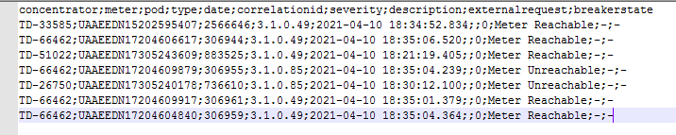

Report

The information about the devices reachability can be see in reports available on the website (real time updated) and on daily csv extractions.

In “Concentrator in field” report it’s possible to see concentrator information.

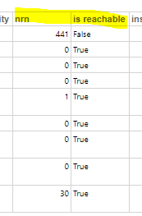

In “Meter in field” report it’s possible to see meter information.
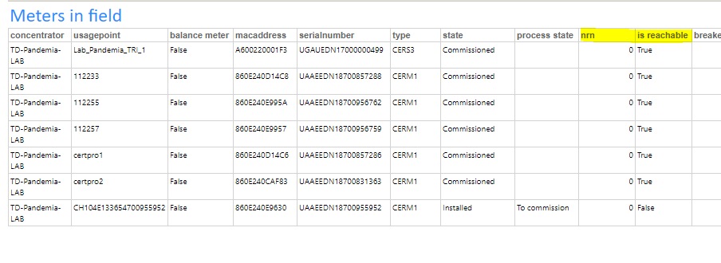
The same extractions are done every night and are available on the storage.

Map
In the “Map” section of the website, it’s possible to select a concentrator and view all associated meters.
Icons are colored based on the status of the devices (reachable/unreachable, commissioned ...)
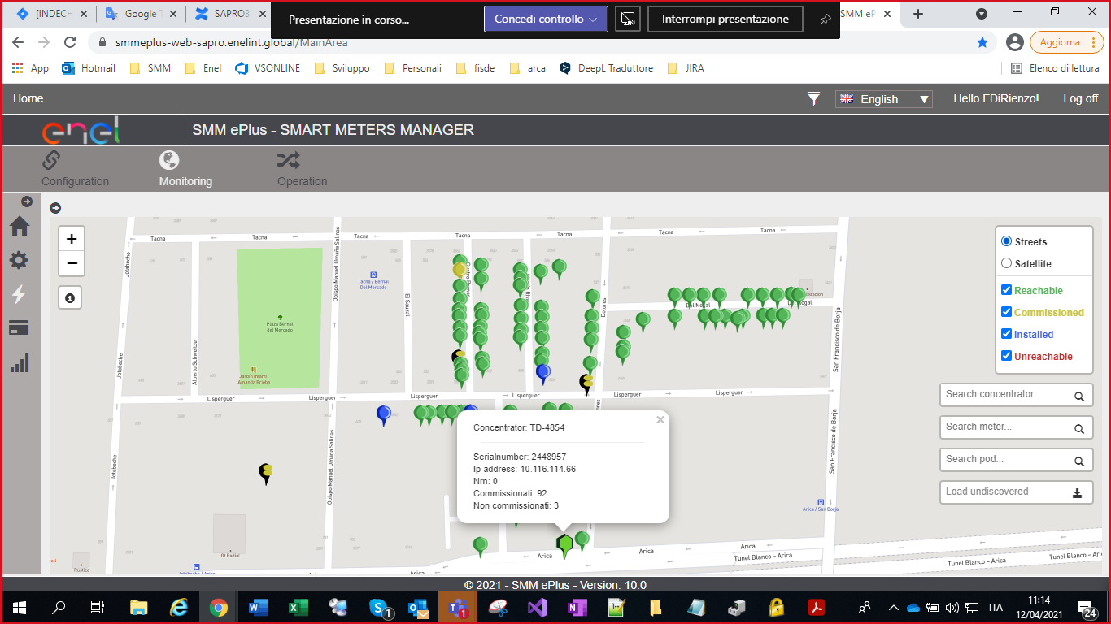

Alarms

Meters

Meters alarms are collected in several ways, on demand and automatically:

- During every commercial workorder, requested via website or though integration.
- During “meter autodiagnostic” technical workorder, available on website.
- During load profile and daily closure collection: the system gets the value of meter status words collected by concentrator during last n2pload procedure.

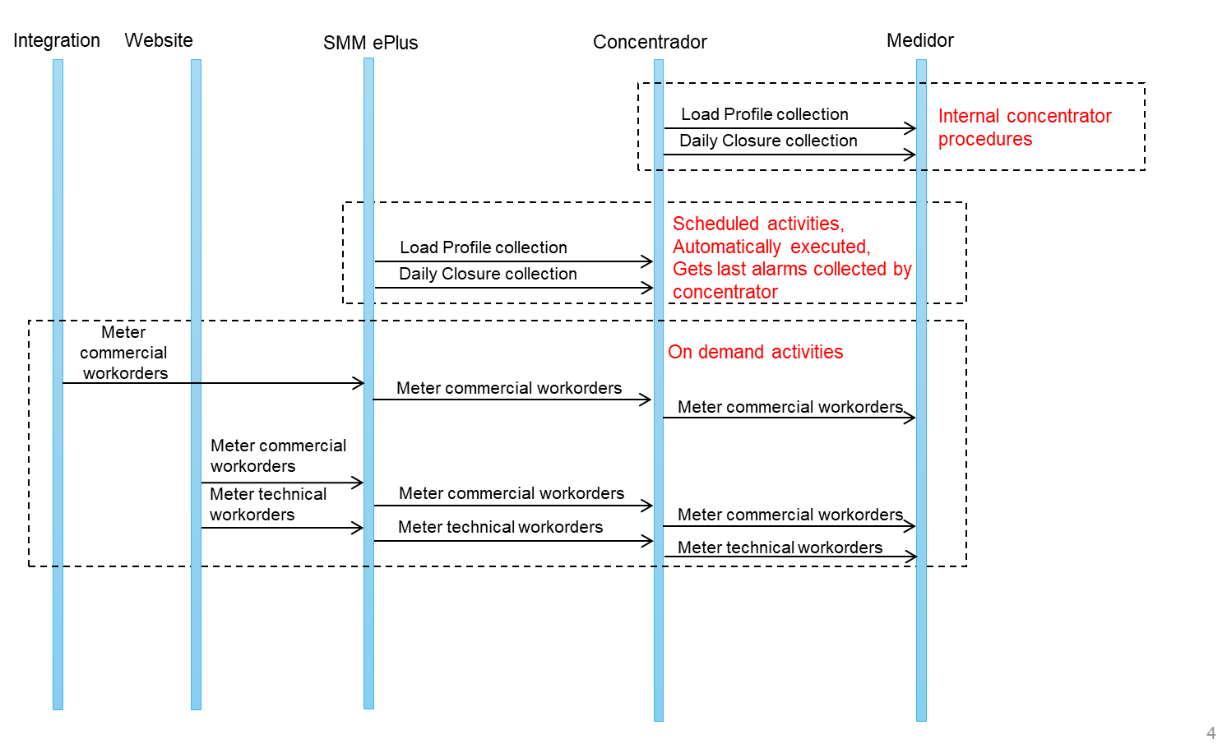

Each alarm can generate a specific events, containing the identification of device, the identification of the alarm and the timestamp.

The system provide the possibility to configure the alarms that has to generate the events and alarms that hasn’t to generate the events.

This is the list of alarms that can be generated in current version of the system regarding meters.

PUP | 3.26.0.85 | There is a power out
ORD | 3.36.17.85 | Clock not aligned
ONSI | 3.36.17.79 | CE without temporal reference
AFC | 3.23.1.79 | Alarm on communication line
SGR | 3.18.17.88 | Data segregated
WDOG | 3.37.0.85 | Watch dog alarm
INTA | 3.26.17.43 | Consumption with circuit-breaker open
CAPE | 3.12.29.212 | Meter case opening
DRAM | 3.18.85.85 | RAM Diagnostics
DEEP | 3.18.42.85 | EEPROM Diagnostics
DFLA | 3.18.92.85 | FLASH Diagnostics
DZCR | 3.21.0.85 | Zero crossing circuit diagnostic
MAGN | 3.12.66.257 | Magnetic Field Application
UNLOCKED | 3.12.298.62 | Lock
DDSP | 3.13.17.85 | Display circuit diagnostic
OLU | 3.12.60.88 | Optical interface locked out due failed password attempts
KP_ON | 3.12.32.62 | Provisional Keys
NCO | 3.15.17.22 | Non cut-off function
BAT_LOW | 3.2.22.150 | Battery alarm
TC_REM | 3.12.29.79 | Terminal cover removed
WRNTHD | 3.20.81.286 | Warning threshold active
POV | 3.26.38.35 | The POV procedure has a positive result
DMIS | 3.21.67.85 | Measurer circuit diagnostic
NPR | 3.12.202.76 | Non-protected Read enabled
NPW | 3.12.282.76 | Non-protected Write enabled
DBT_LMT | 3.20.81.150 | Debit Limit

Concentrators

Every time the system connects to a concentrator, the alarms are collected and saved in database. It’s possible to consult last concentrator status word value in “Concentrator in Field” report available on website.
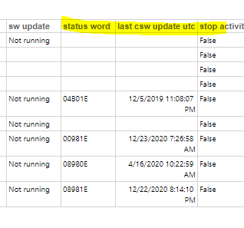

The same information is also available in the daily csv “ConcentratorInFieldReport”.

For concentrator status word no event is exported, but the analysis of most important active alarms can be found in daily csv “ConcentratorStatusWordAnalyzedReport_yyyy-mm-dd”.csv
A power up | CERCO Power up
S ModeCha | CERCO functioning modality variation (standalone/remote)
T Amm | Expired time-out communication with AMMS.
L Tamper Detection | Tamper Detection
F ConnC | CONN-C procedure completion.
U PLC Modem Failure | PLC modem failure
C Time Zone Enable | Time Zone handling enabled/disabled
M Available | Not used
I PhaseR Missing | Phase R missing
J PhaseS Missing | Phase S missing
K PhaseT Missing | Phase T missing
Y CBT Diag | Reserved for CERCO diagnostics.
Z Post | Error in CERCO self-diagnostics
B CE Table Load | CE Table loaded
O Sync | CERCO Synchronised (with valid temporal reference)
E LVAct | Communication active on LV net
G DST | Daylight saving time period configured.
R Dis | Not used

Features

This is the complete list of features of the system:

- Concentrator technical configuration.
- Concentrator syncronization (at the end of each activity).
- Concentrator status word collection (at the end of each activity).
- Concentrator firmware update.
- Custom script execution on concentrators.
- DST configuration on concentrator.
- Concentrator Mutual Authentication configuration.
- Concentrator Repeater table reading.
- Load profile collection.
- Daily Closure collection.
- Voltage variation collection.
- Voltage interruption collection.
- Measurands collection.
- Autodiscovery results collection.
- Meter technical configuration.
- Meter syncronization.
- Meter autodiagnostic (reset and read status word).
- Commercial meter workorders:
  - Reading (local and remote)
  - Maximum power reading.
  - Detachment (local and remote).
  - Reconnection (local and remote).
  - Reduction (local and remote).
  - Tariff/contract configuration (no possibility to create new tariffs/contracts in the system yet).
- Prepayment management:
  - Prepay configuration / disable (local and remote).
  - Credit charge/reduction workorder (local and remote).
  - Credit read workorder (local and remote).
  - Automatic credit and alarms through CEData.
- Custom script execution on meters.
- DST configuration on meter.
- Meter firmware update.
- Meter status word collection during commercial workorder, daily closure and load profile collection.
- Daily report extractions (collected data and alarms).
- Concentrator wake up listener
- Last Gasp concentrator listener
- Last Gasp meter listener

Especificación técnica de Sistema de Seguridad

Meter and concentrator keys

When commissioning is completed, the “meter technical configuration” activity switches the meter keys from public to private ones. Concentrator keeps the keys of recruited meters in its database.

The couple of keys of meters and concentrators are unique.
Meter and concentrator keys are stored encrypted in internal database.

Logs

In relation with logs of activities, there are several types of information:

Website:

- Each website logs activities in a text file per each day.
- These files are saved in the same FTP folder of the web site and are never deleted.
- To access the FTP it’s required the username and the password.
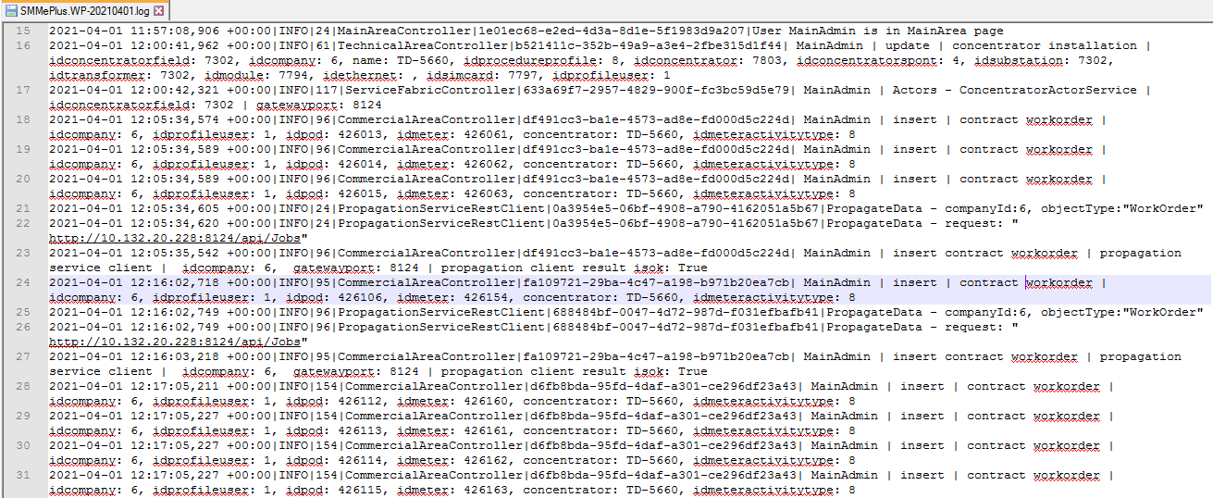
Backend:

- The services in backend logs in text files in the file system of the servers.
- These logs are used in case of specific analysis, usually if an activity has some problems in execution.
- To access these logs it’s necessary to have local access to servers of the cluster.
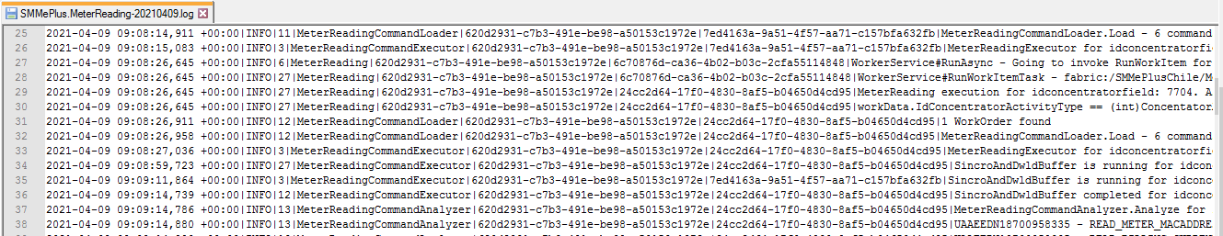

Database:

- As described Infrastructure document, SQL Auditing feature is enabled and writes on Azure Storage Explorer the logs of queries and stored procedure, success and failed log in.
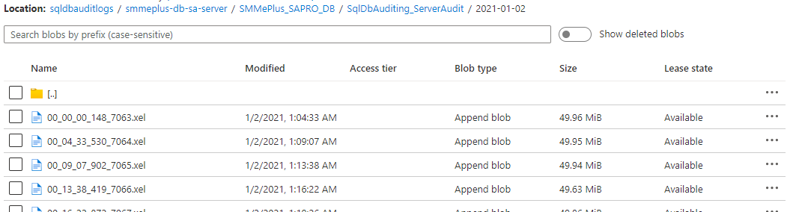

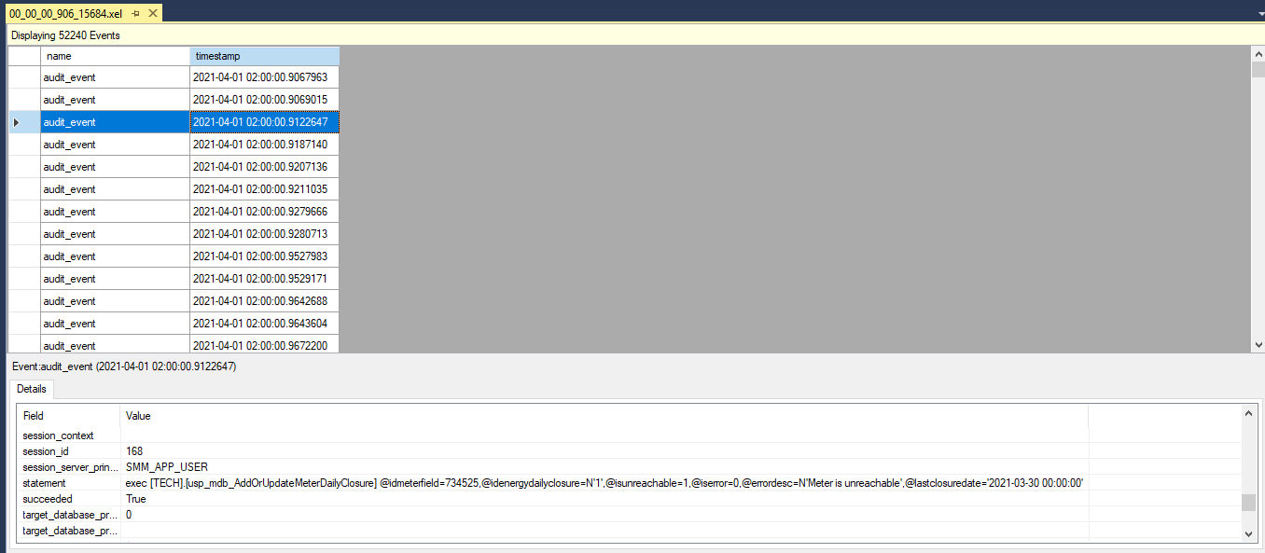

Report:

- In The HES website, reports are used to check results of activities in the system.
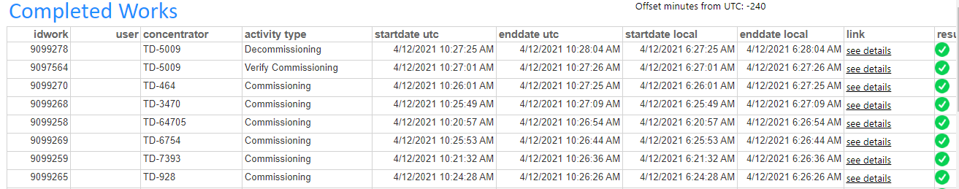

Data Integrity

In relation with collected information, data are immediately pushed to cloud queues and can’t be modified from the user.

Data Confidentiality

The website is accessible from Enel network and csv files provided by the system can be accessed using a connection string.
Certificates are necessary for deployment operations.

User permissions

Especificación técnica de Sistema de Sincronización Horaria

Meters

When a meter is recruited by a concentrator, the concentrator is in charge of meter synchronization.

In addition, the system provides the possibility to force the concentrator to synchronize the meter using the concentrator own time.

This technical meter workorder is called “Meter Synchronization” and can be generated in two ways:

- The user, through the website, manually generate the activity
- The system receives a specific alarm regarding clock not-synchronized and automatically generate the activity (this feature can be enabled or disabled).

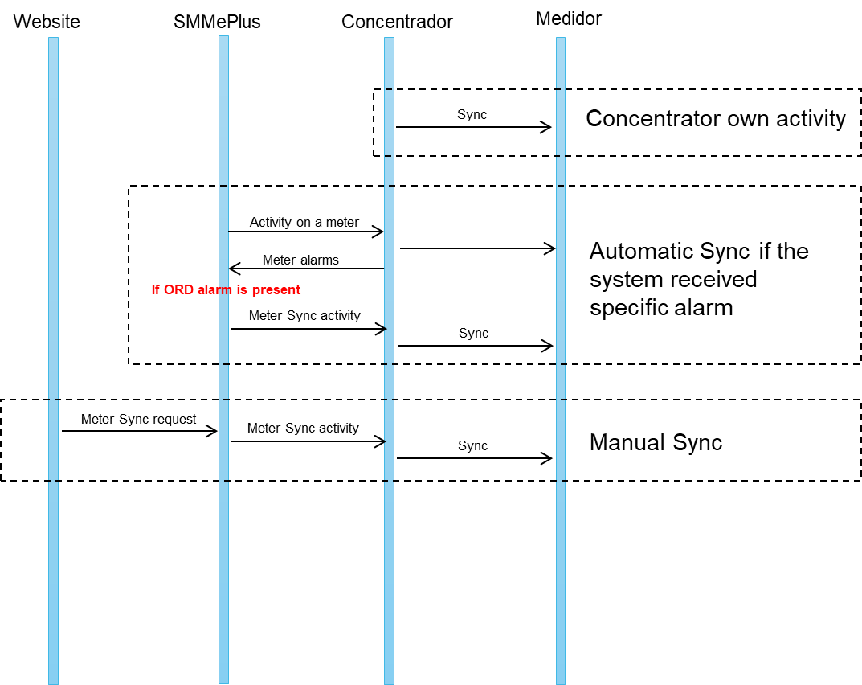

Concentrators

The concentrator is synchronized by the system at every connection. Connections consist of:

- Scheduled operations, executed automatically by the system.
- On demand operations, executed by the user through the website on concentrator and meter.
- On demand operations, required via integration by integrated system.

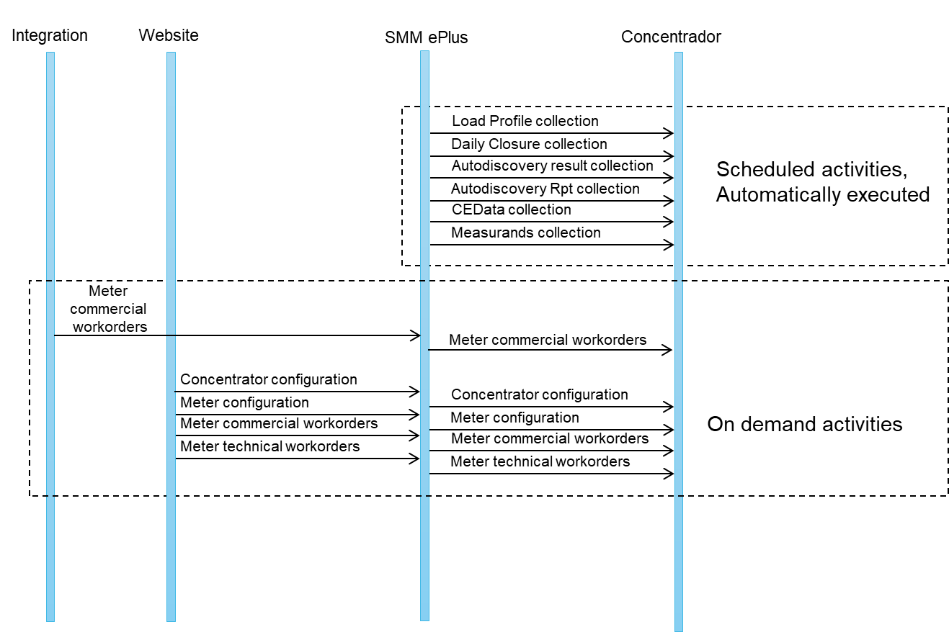

The servers hosting the services of the system are not configured with local time. The servers are configured with UTC time and the system is in charge of the conversion from UTC to local time before executing the synchronization activity.
NTP protocol is used by “Windows Time” service that is running on each SMMePlus server and maintains time and date synchronization.

In the system database, two tables are in charge of storing timezone values:
- Timezone table.
- Daylight Saving Time table.

Especificación técnica de Sistema y Aplicaciones

Especificación técnica de DB para Operador de Datos

http://confluence.enelint.global/display/STARBEAT/Product+Catalogue+-+STAR+BEAT

http://confluence.enelint.global/display/STARBEAT/IN+-+StarBeat

Especificación técnica de Interfaces para Interoperabilidad (relativa a la Plataforma y medios de comunicación)

I0
Permissions are not defined at interface level, but, for each kind of activity, it’s possible to give/remove permissions to users. The mobile application of The HES manages local activities with meters, but doesn't manage local activities on concentrators yet.

I1
It’s possible to see values from the display of the meter.

I4
The system can access concentrator with or without specific authentication and can send read or write commands.

I5

The database of the HES can be consulted using the reports available on website and the daily extractions.

I6
Data collected by The HES are pushed on Event Hub queues (Microsoft Azure) that are shared with distribution company. The integration service of local country has the key for connecting with the Event Hub with read-only permissions.
The data collected by The HES are also pushed on csv files, shared with local country using a cloud storage that, now, are accessed with a connection string that allows read and write control.
In order to specify read or write permission the “Shared access signature” property of Azure Storage Account could be used.
In the other direction (from local systems to The HES), The HES exposes a service in the intranet that is used to provision information and request activities.

I7
Reports of the website uses the read-only replica of database.

I8
A specific table of read-only replica database is accessible from Stakeholders.

I9
Reports of the website uses the read-only replica of database.

I10
A specific table of read-only replica database is accessible from Stakeholders.

Especificación Técnica de Almacén de Datos y Reportes

The HES provides reports in three ways:

Website

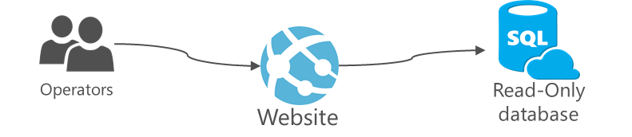

On website several reports are available and are always updated. The description of reports available on website is described in SMMePlus_UserManual v1.35 in section 9 Report.

Daily csv
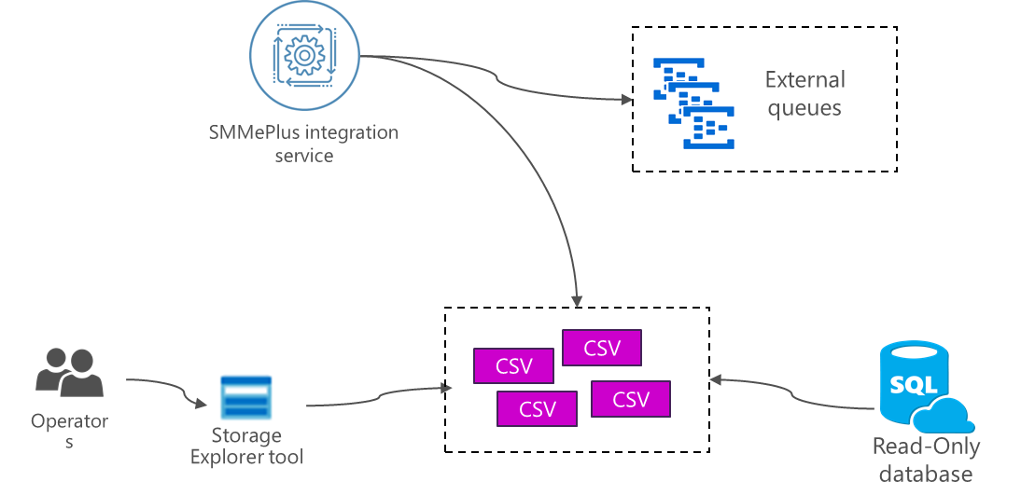

Daily extraction from read-only database
Csv files are extracted usually once a day from read-only database and contains massive information for all managed devices. The available reports are regarding:

- Activities in progress and completed.
- Detachment and reconnection executed.
- Meters status.
  - Reachability.
  - Collection of information.
  - Configuration.
- Concentrator status.
  - Reachability.
  - Configuration.
  - Scheduled activities execution.
  - Aggregated statistics for recruited meters.

The detailed description of csv extraction is described in SMMePlus - Architecture v4.0 in section 2.5.1.1. CSV file.

Daily files from integration

SMMePlus Integration Service is the component in charge of integration between SMMePlus and External Systems.
As described in SMMePlus - Architecture v4.0 in section 2.5. SMMePlus Integration Service application, the SMMePlus integration service creates every day one or more csv files containing:

- Readings.
- Load profile.
- Voltage Variation.
- Events and alarms.
- Measurands (currently developing).
- Voltage Interruptions (currently developing).

BD repository

The BD repository have all the information about the readings, alarms, load profile and POD information.
Until now, following views are available for Business for a direct consultation. Views are on a read-only database and can’t be modified.

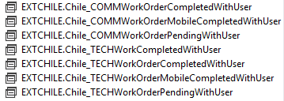

Chile_COMMWorkOrderCompletedWithUser
Gives information about commercial workorder that have been created though the website of the system.

Chile_COMMWorkOrderMobileCompletedWithUser
Gives information about commercial workorder that have been executed locally on the meter using the mobile application.

Chile_COMMWorkOrderPendingWithUser
Gives information about commercial workorder that have been created though the website of the system and are not completed yet.

Chile_TECHWorkCompletedWithUser
Gives information about on-demand activities sent to concentrator and already completed. This report includes activities related to concentrator and related to meters.

Chile_TECHWorkOrderCompletedWithUser
Gives information about remote activities executed on meters. This report includes commercial and technical read/write operations, requested from website, from external system or automatically generated.

Chile_TECHWorkOrderMobileCompletedWithUser
Gives information about technical workorder that have been executed locally on the meter using the mobile application.

Chile_TECHWorkOrderPendingWithUser
Gives information about remote activities on meters not completed yet. This report includes commercial and technical read/write operations, requested from website, from external system or automatically generated.

Local database
The SMMePlus integration service pushes all collected information on cloud queues that are consumed by local services.
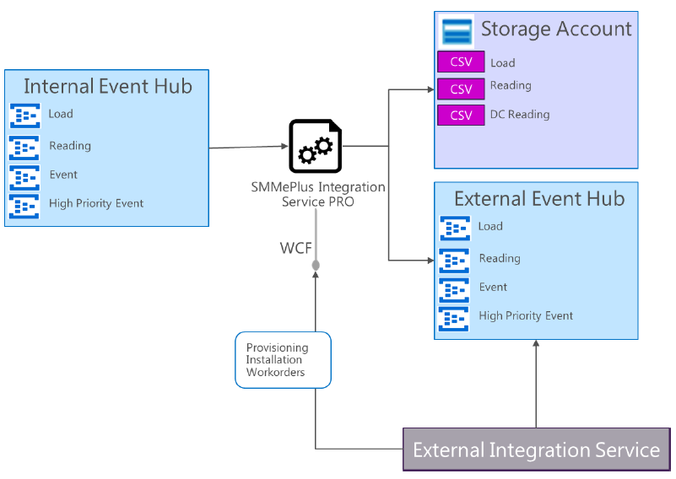

The integration provided by the system is described in:

- SMMePlus - Architecture v4.0 in section 2.5.1.2. External Event Hubs
- SMMePlus - Requirements - Integration 2.4

